Animal Cell
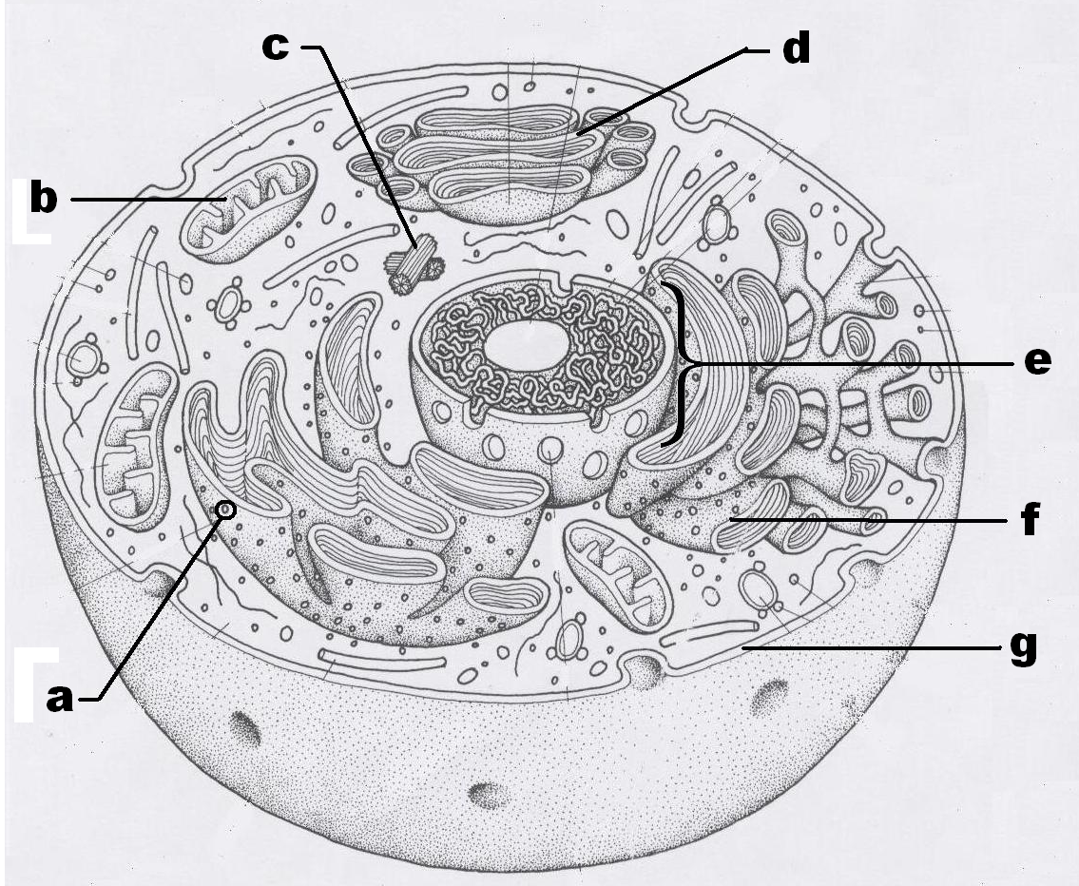

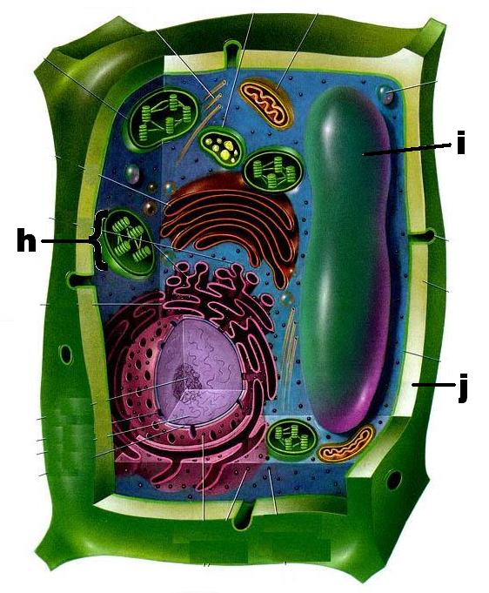
Plant Cell

HOW ARE PLANT CELLS DIFFERENT FROM ANIMAL CELLS?

Plant cells and animal cells are not exactly alike. Plant cells have certain parts that animal cells do not. These parts are a cell wall and chloroplasts.
CELL WALL – The cell wall surrounds the cell membrane of a plant cell. The cell wall is made of a non-living material called cellulose. The cell wall is more rigid (stiff) than the cell membrane. It gives a plant cell its stiffness. It also gives it its shape.
CHLOROPLAST - Chloroplasts are found in the cytoplasm of a plant cell. Chloroplasts contain a green substance called chlorophyll. Chlorophyll is needed by green plants for food-making. The food-making process of green plants is called photosynthesis. Most chlorophyll is found in the leaf cells of green plants.
Plants can make their own food. Animals cannot. Animal cells do not contain chlorophyll.
The number and size of vacuoles also is different in plant and animal cells. Plant cells have only one or two vacuoles. The vacuoles are usually very large. Animal cells have many small vacuoles.

Plant vs. Animal Cells
1. What two parts do plant cells have that animal cells do not have?
_______________ and ________________

2. What is the cell wall made of? __________________
protoplasm, cellulose
3. Is cellulose living material? ____________________
yes or no
4. Where are the chloroplasts located? __________________________
in the nucleus, in the cytoplasm
5. What substance is found inside the chloroplasts? ___________________
protoplasm, chlorophyll
6. What is the substance inside the chloroplasts used for? _________________
food-making, excretion
Complete the Chart
Answer the questions by putting “YES” or “NO” in the space provided.

 | Animal Cell | Plant Cell
1. Does it have a nucleus?
2. Does it have ribosomes?
3. Does it have mitochondria?
4. Does it have a cell membrane?
5. Does it have a cell wall?
6. Does it have cytoplasm?
7. Does it have chloroplasts?
8. Does it have an endoplasmic reticulum?
9. Does it have chlorophyll?
10. Does it have many small vacuoles?

Identify the organelle or term described by the following definitions

1. ____________________ The smallest living thing.
The structural and functional unit of life.

2. ____________________ Holds the contents of plant and animal cells in
place.

Regulates the movement of materials into and out of the cell

3. _____________________ Organelle that contains the green pigment chlorophyll used in photosynthesis.

4. _____________________ Genetic material found in the nucleus of a cell

5. _____________________ Organelle that stores and packages protein molecules.

6. _____________________ Organelle that assembles proteins (“site of protein synthesis”)

7. _____________________ A sac-like organelle, filled with digestive enzymes, that can break down large molecule and other cell parts.

8. _____________________ Surrounds the cell membrane of a plant cell
Protects and supports the cell

9. _____________________ Any structure found in the cytoplasm of the cell that has a specific form and function

10. ____________________ Organelle responsible for the transport of materials within the cell

11. ____________________ Oval shaped organelles that produce energy for the cell “ Powerhouse of the cell”

12. ____________________ All interior components of the cell except the nucleus. The area within the cell where nutrients are absorbed, transported and processed.

13. ____________________ An organelle which can store water, sugar, minerals and proteins. Much larger in plants than in animals.

14. ____________________ Control centre of the cell
Stores genetic information and directs the activities of the cell.

